National University of Computer and Emerging Sciences

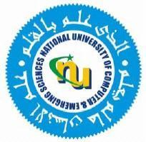

Laboratory Manual
for
Operating Systems Lab

(CL-2006)

Course Instructor | Ms. Rubab Anam
Lab Instructor | Muhammad Faheem
Section | BCS-4F
Semester | Spring 2025

Department of Computer Science
FAST-NU, Lahore, Pakistan

Objectives
In this lab, students will practice forks.
Basic scheme of fork and exec

pid_t parent = getpid();
pid_t pid = fork();
if (pid == -1) { // error, failed to fork() }
else if (pid > 0) { int status; waitpid(pid, &status, 0); }
else {
// we are the child execve(...);
_exit(EXIT_FAILURE); // exec never returns }
The parent knows the child's id through fork return and can store it. While exec will not return to the same program after successfully executing.

Lab Questions

Question
Write a program to produce a binary fork tree of height 3. This means there would be a main program, root of the tree and it will have 2 children and each child will then have 2 children and so on so that the total height would be 3. Use the wait system call judiciously and handle any error conditions.

